**Project Title:** Hotel Reservation System

**Final Phase:** Review Sprint-Report

**Group Members:**

Abdullah i19-1772

Majid Ahmad i19-1796

**Nature of Project:** Web Application

**Introduction**

So, we this hotel reservation system for hotels so that they can use an online reservation system and customers can use an online system to book rooms. Our main focus was to make an aesthetically pleasing website and smooth payment option so that both customers and the hotel is happy, also the main point of this system was to simplify the process.

Functional Requirements:

The hotel reservation system should be able to empower clients to look and track down the most appropriate booking choices

Look up the availability of rooms when user/customer enters date and time

The website should be able to able to lookup the prices of accommodation and utilities, and add those and minus any discount and display it to user

Cancel any appointments made by user

Show and change records of visitors

The manager or an admin of hotel reservation system should access the records of each customer/visitor.

**Non-Functional Requirements:**

The search results for room availability should be shown in acceptable limits

Clients ought to be helped suitably to fill in the required fields if there is an error is raised by validator of system

The framework ought to acknowledge payments by means of different payment options such card or COD

The hotel reservation system should be simple to utilize, productive, and open to responses

Monitor documentation, exercises, and reactions from users so that system can be updated any time.

**Sprint Backlog and Output**

In the last iteration we had completed the last 3 modules and completed the project. We have added a system where user can pay using credit card or cash. We had added a feature that when a user makes a booking an email confirmation is sent to his name this results in a more secure web app. Also, we have implemented email confirmation or user changing a booking, thus increasing security of applications.

**User Stories we have selected**

|  |  |  |  |  |  |  |
| --- | --- | --- | --- | --- | --- | --- |
| **Serial no.** | **Objective/Task** | **User Story** | **Users and task explained** | **Priority** | **Sprint** | **Status** |
| 1 | Room online reservation | Create new rooms | As a user(customer) I want to be able to be able to view all rooms in order to know which are available | Must | 1 | Completed |
| 2 | Home Page | Aesthetically pleasing webpage | As a user who is customer he wants a website that is intereactive and aesthectically pleasing |  |  |  |
| 2 | Room online reservation | Edit room information | As a user of system admin, I want to be able to see up to date information on the room in order to decide if it meets my requirements and change it | Must | 1 | Completed |
| 3 | Room online reservation | charges | As a user (system admin) I want to be able to be able to set room charges and utilities they offer | Must | 1 | Completed |
| 4 | Room online reservation | Room online reservation calendar | As a user I want to be able to see the availability of all rooms at a location on a calendar by date in order to check the availability and book a room | Must | 1 | Completed |
| 5 | Room online reservation | online reservation summary in calendar | As a user(admin) I want to be able to see a summary of the existing room online reservations in the calendar in order to see what the room is booked for and who has made the online reservation | Must | 1 | Completed |
| 13 | System | External create account | As an external user I want to be able to create an account in order to log back in to view and amend online reservations | Must | 1 | Completed |
| 14 | System | External log in | As an external user I want to be able to log into my account in order to view and amend online reservations | Must | 1 | Completed |
| 6 | Room online reservation | View room online reservations | As a user(customer) I want to be able to view my room online reservations in order to check my online reservation | Should | 2 | Completed |
| 7 | Room online reservation | Cancel room online reservation | As a user(customer) I want to be able to cancel room online reservations in order to remove them if no longer required | Must | 2 | Completed |
| 8 | Room online reservation | Change room online reservation | As a user(customer) I want to be able to change room online reservations in order to amend if required | Must | 2 | Completed |
| 9 | Visitor | Change visitor details | As a user(admin) want to be able to change visitor details in order to be able to amend if required by customer | Must | 2 | Completed |
| 15 | System | Pay for online reservation by credit/debit card online | As a user I want to be able to pay for my reservation online using my credit/debit card in order to complete my online reservation | Could | 3 | Completed |
| 16 | Notification | Email confirmation of a change to room online reservation | As a user I want to receive an email confirmation of my room change in order to have reassurance of my change | Must | 3 | Completed |
| 17 | Notification | Email confirmation of online reservation | As a user, I want to receive an email confirmation of my room booking | Must | 3 | Completed |

**Architecture Model**

The Client-Server model is a type of model we chose to implement so we can provide the customer with a booking option from a server so we had to choose a client-server model. We have explained with a diagram how our files are arranged with an explanation in the diagram.

To explain how our client-server model works let’s take an example of when a user is registering on a website. The user request a register page to server then the server process the HTTP request of users to urls.py to find the requested page and the urls.py forward request to the appropriate view of by using views.py the views.py fetch HTML page and sends to the user on his web browser. The HTML page resides in the Templates folder as shown in the diagram. When the user enters his record, he now uses the server to save his record, when user click the submit button the HTTP request uses urls.py and response from server is used which is written model.py to read/write the data as shown in diagram.

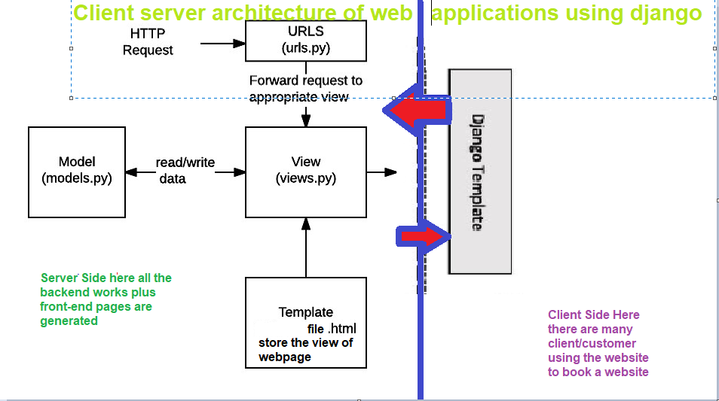

**Snapshots of TRELLO message board**

These are snapshots of the **TRELLO** message board during each phase of implementation. We required 3 phases to implement our hotel reservation system.

Snapshot 1 when implementing iteration 3 start

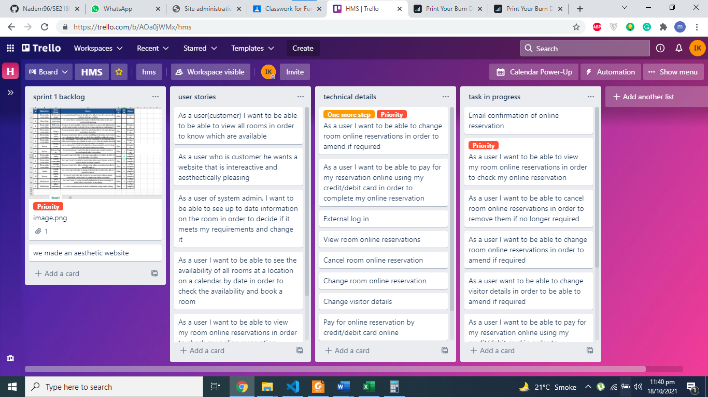

Snapshot 2 when implementing iteration 3 middle of project

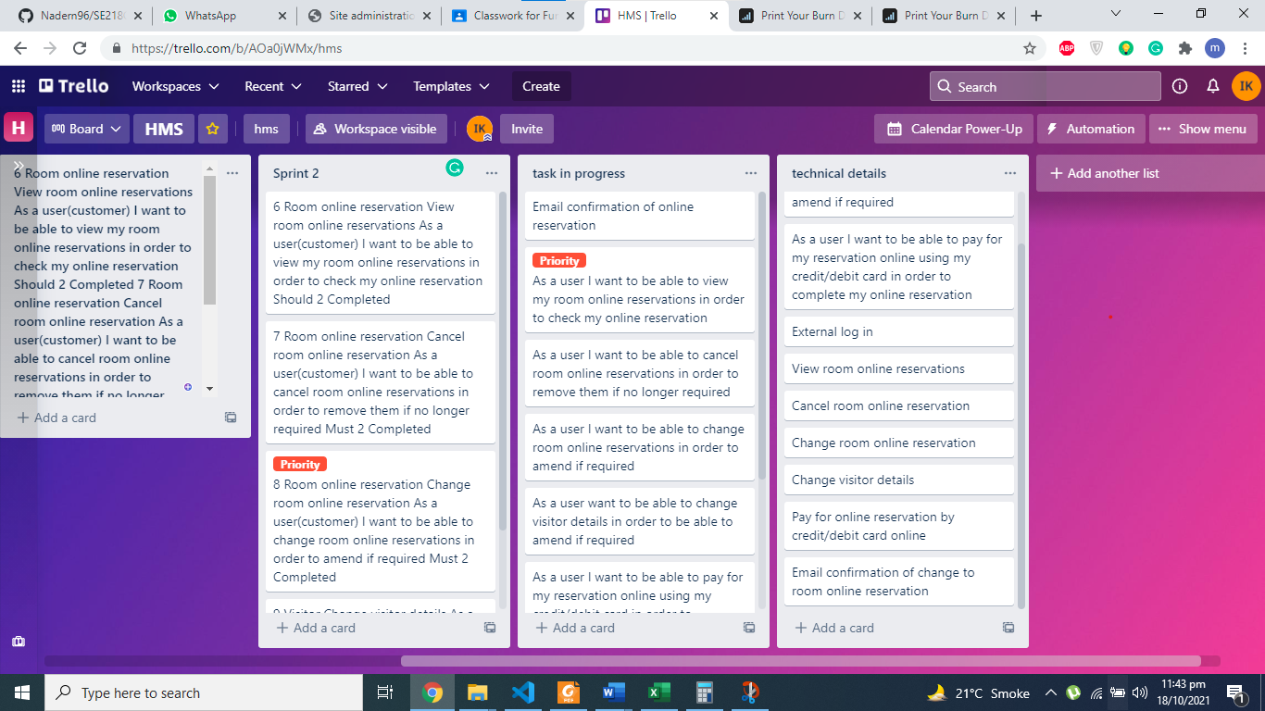

Snapshot 3 when the last 3 user stories were implemented also did monitoring and testing.

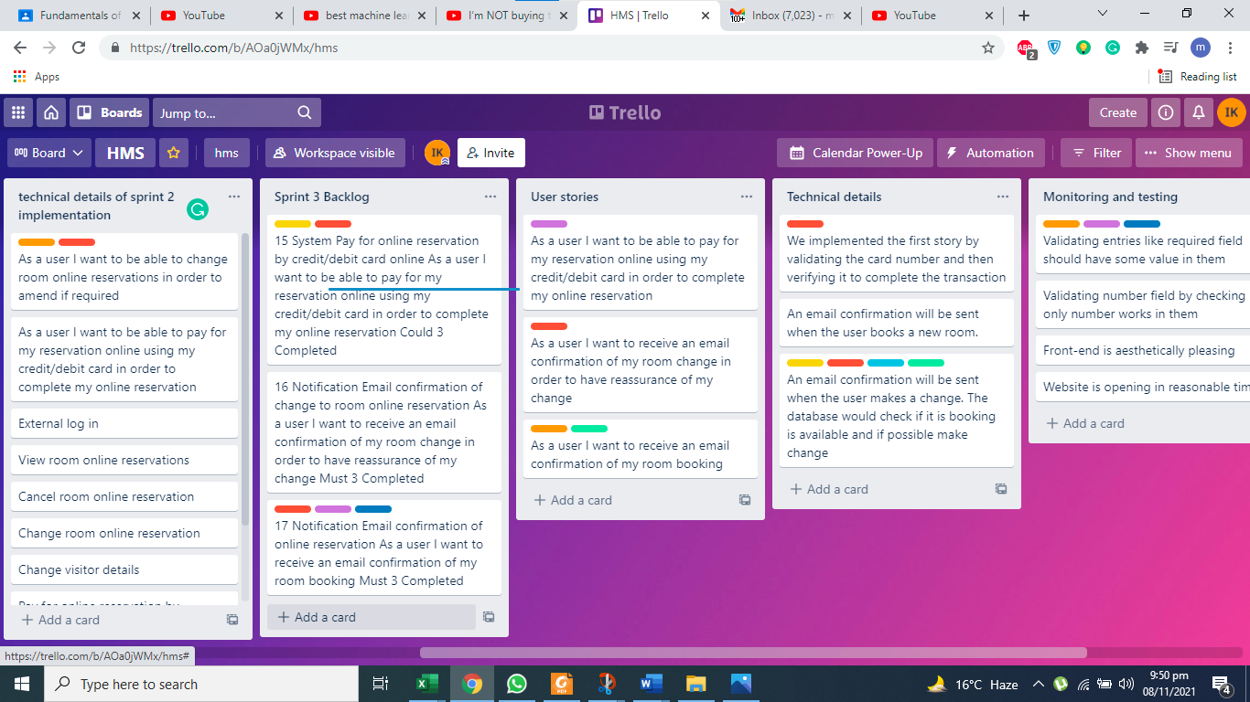

**Burn-down chart**

September 21 🡪 Start date

October 31🡪 End Date

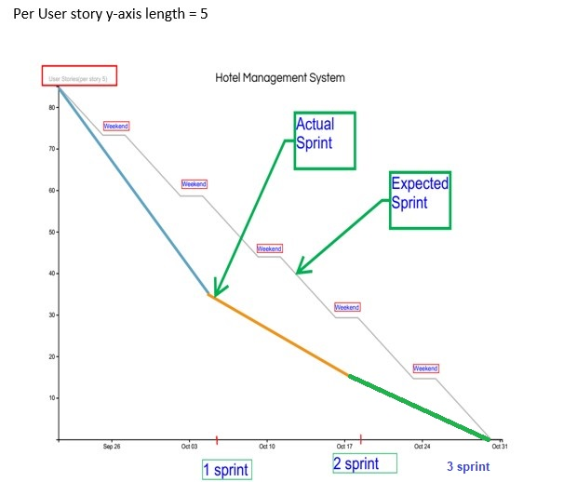

**Monitoring and testing**

**Monitoring**

Front-end is aesthetically pleasing. Also asking user through a feedback form on how to improve website and to rate the website too.

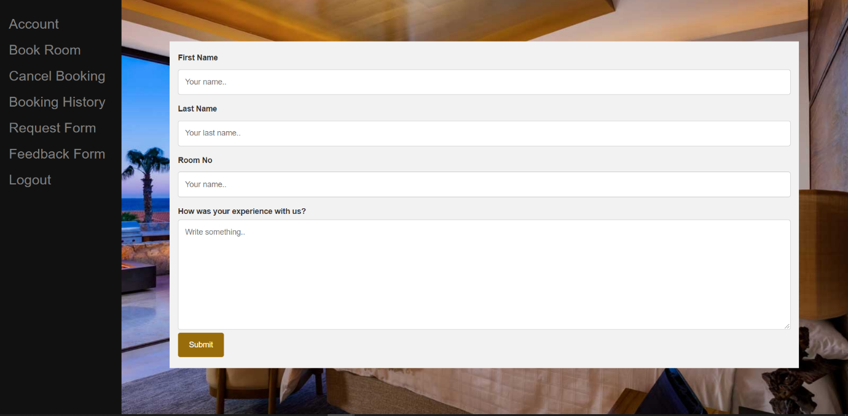

Website is opening in reasonable time and should not take much resources as it should able to run on low powered computers.

GUI with boundary value and equivalent class partitions.

**CNIC field with 13 digits for registration page**

So here the user is asked to enter his CNIC number if it not equals 13 digits it is rejected with a message to saying to user to enter 13-digit CNIC.

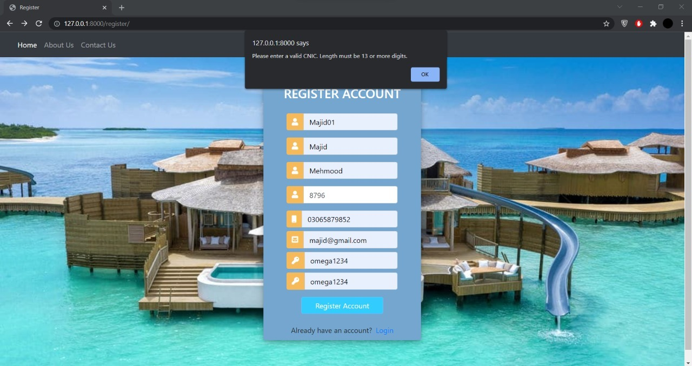

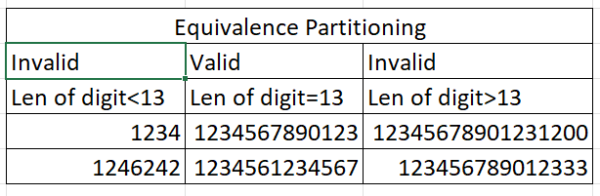

Accepted:

Here you can see cnic is accepted but contact number is wrong so error is showing but not cnic.

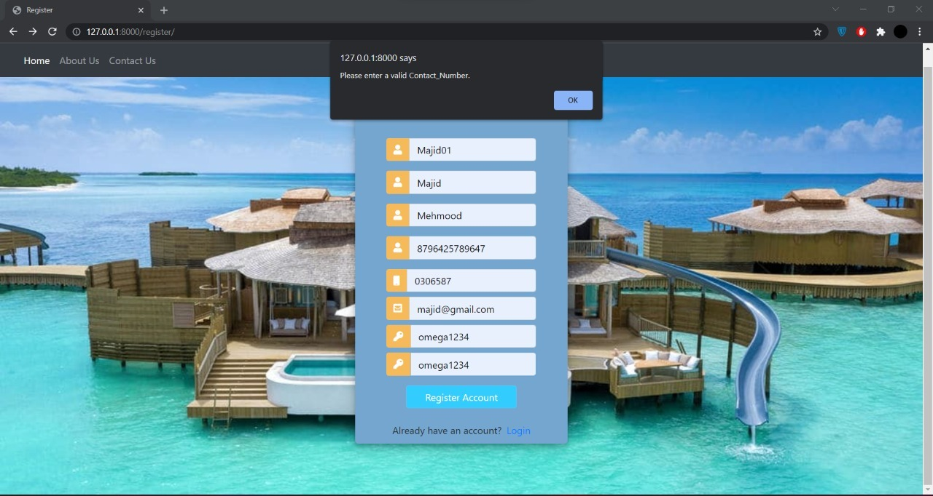

**Password field for login**

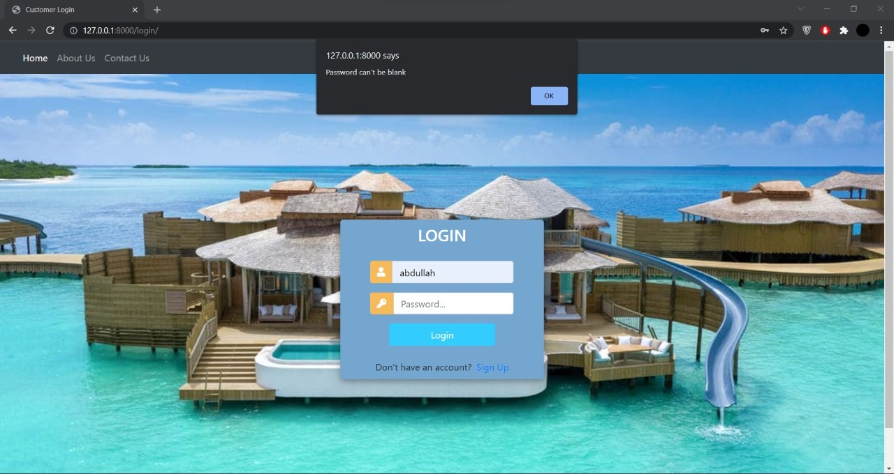 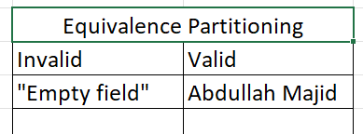

Accepted:

Here password accepted but username left empty so showing error

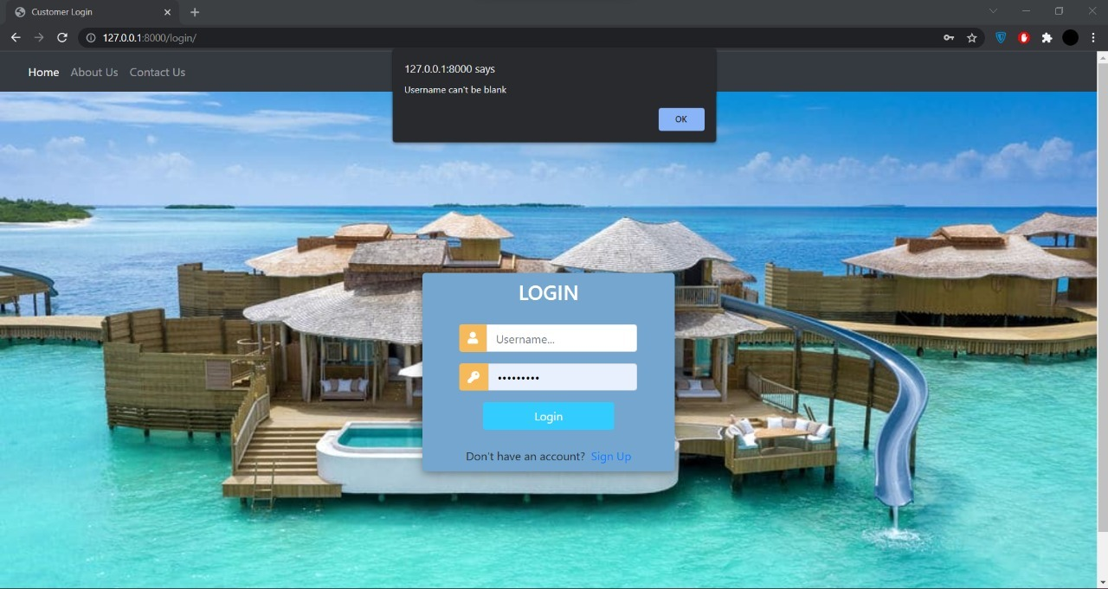

**Contact number**



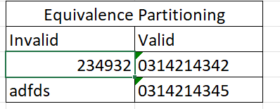

Accepted:

Contact number accepted error showing because of wrong cnic number.



**Email address**

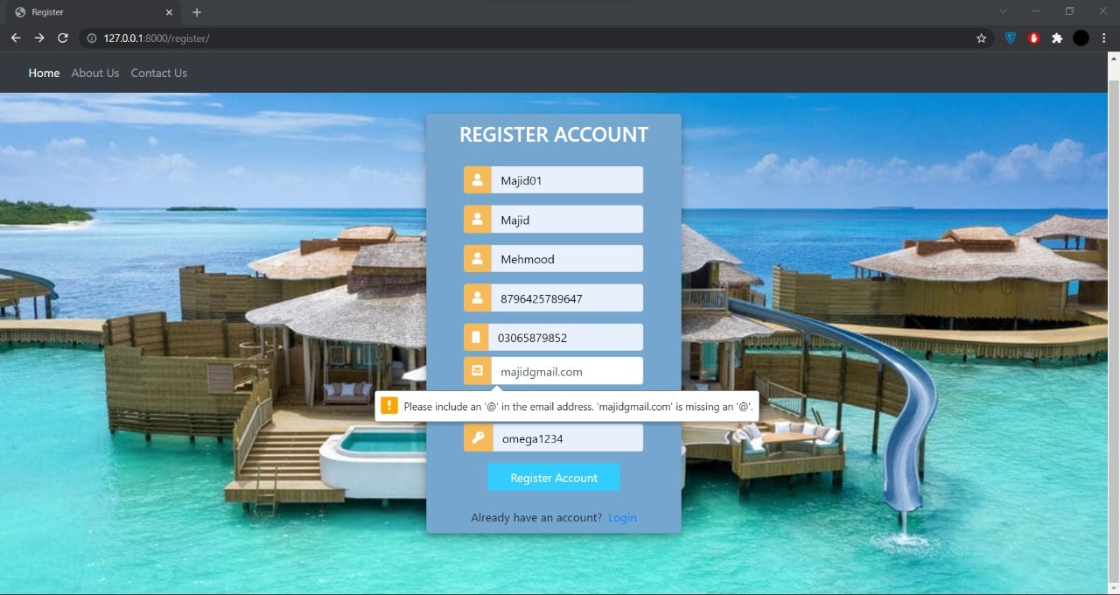

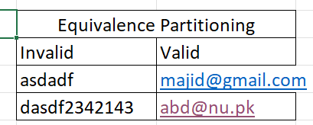

Accepted:

Here you can see email is accepted but contact number is wrong so error is showing but not email.



**Username for login**





Accepted:

Username is accepted but due to no password error given.



**Username for submission**

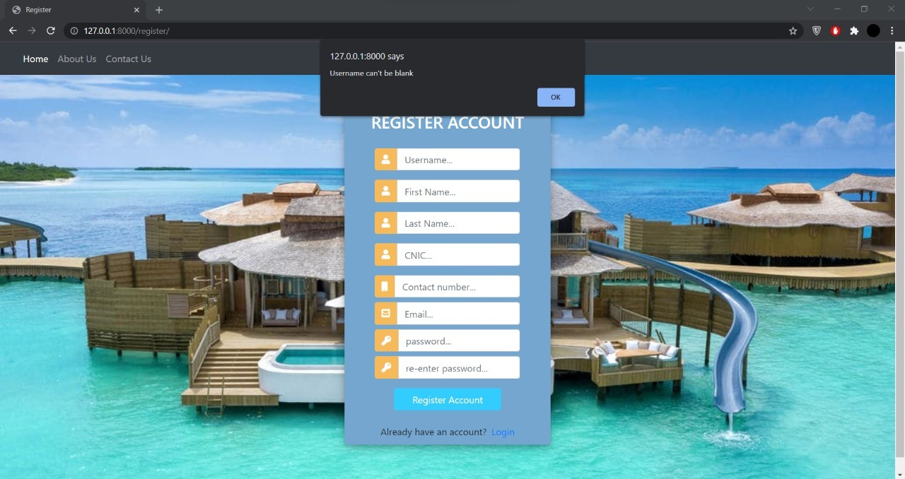 

Accepted:

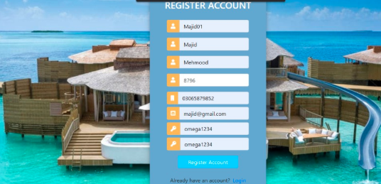

**Form submission**

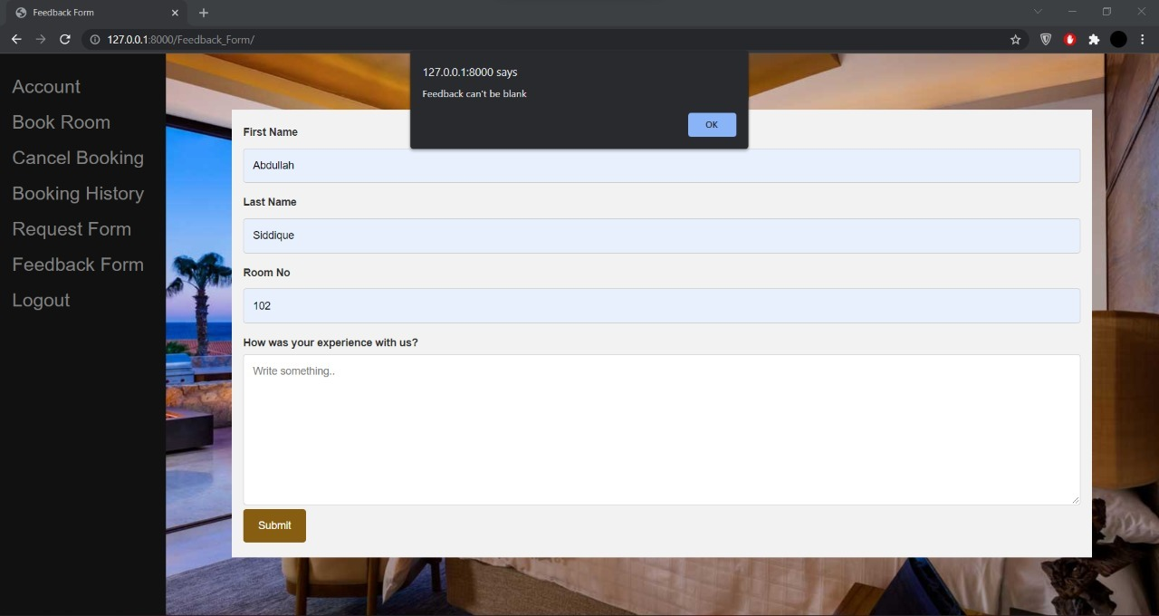 

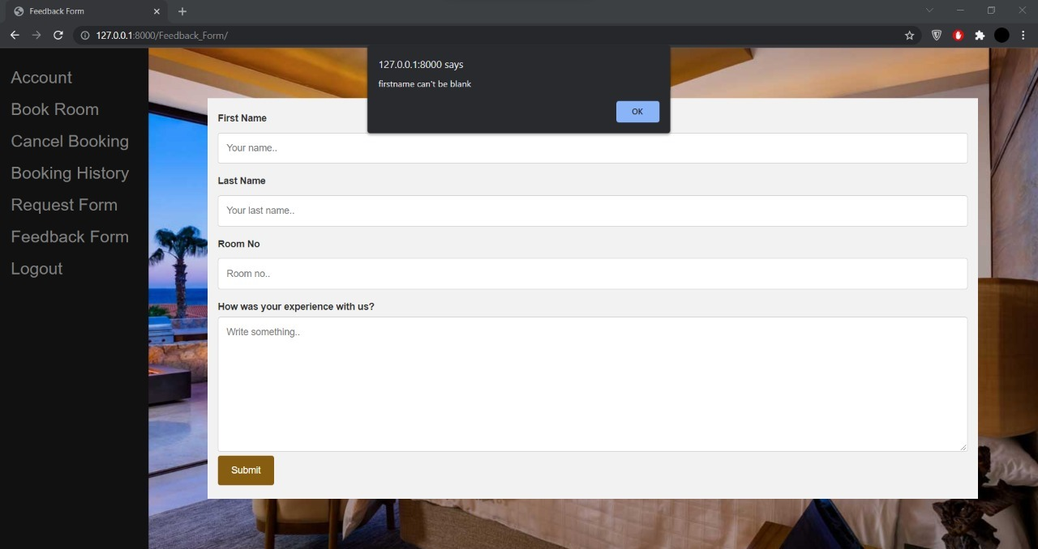 

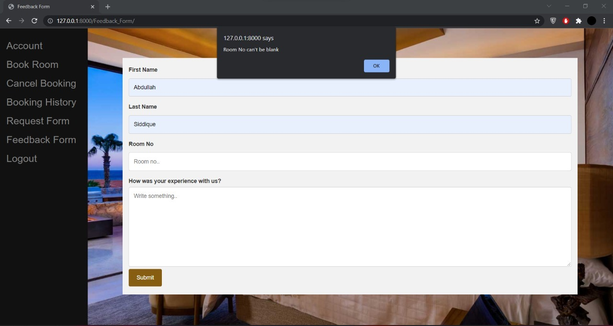 

Accepted

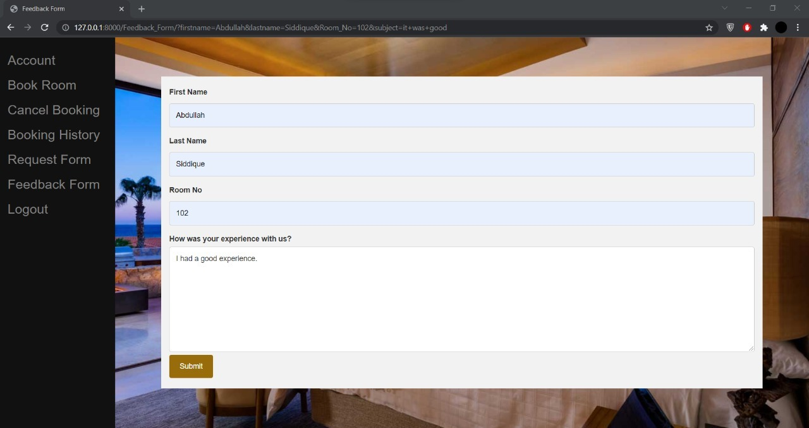

Validating entries like required field should have some value in them like required field (*).

Front-end is aesthetically pleasing. Also asking user through a feedback form on how to improve website and to rate the website too.



**Technical Details of how user stories are implemented (images includes)**

1. As a user(customer) I want to be able to view my room online reservations in order to check my online reservation

We implemented by using django libraries and algorithm developed to support verification of room booking

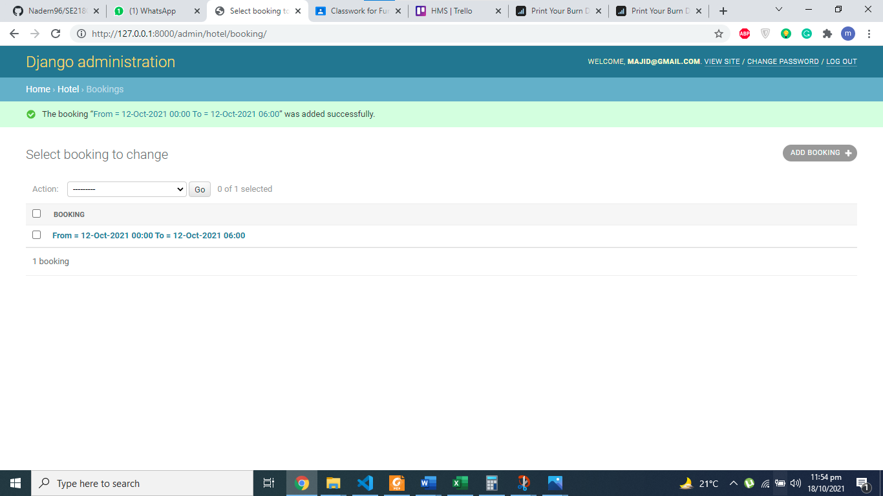

1. As a user(customer) I want to be able to cancel room online reservations in order to remove them if no longer required

We implemented by using Html and algorithm developed to support verify that room indeed has been cancelled



1. As a user(customer) I want to be able to change room online reservations in order to amend if required

To apply we have to first verify user and then he accesses databases and then change his booking this was done using django framework

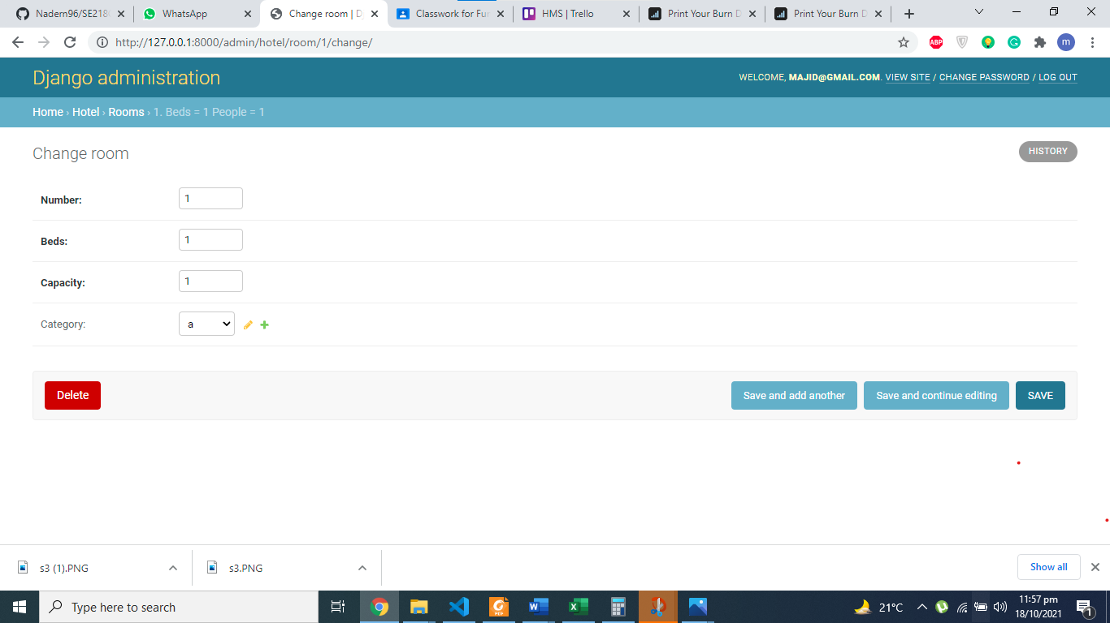

1. As a user(admin) want to be able to change visitor details in order to be able to amend if required by customer

To apply this feature, we had to give admin super access of database so that he can make any changes he wants.

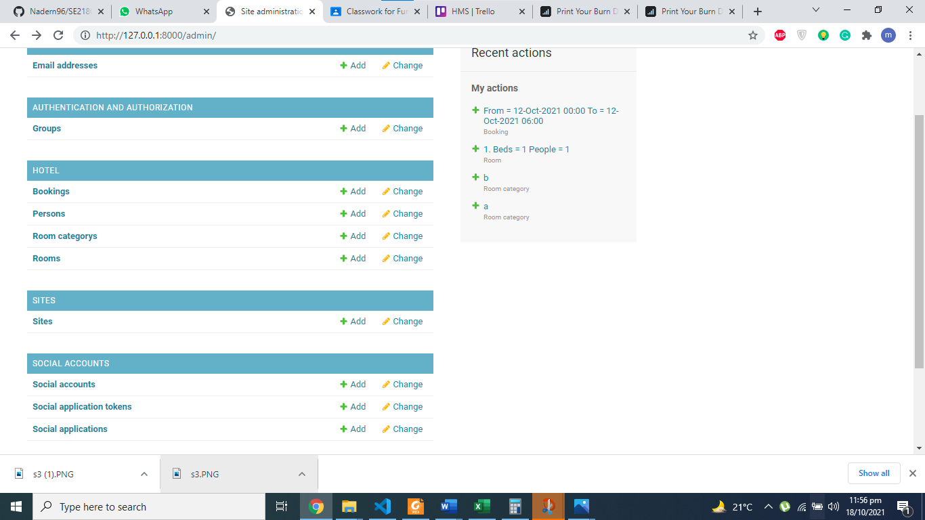

Tested Code with front-end and back-end

register user with shown in DB in next pic

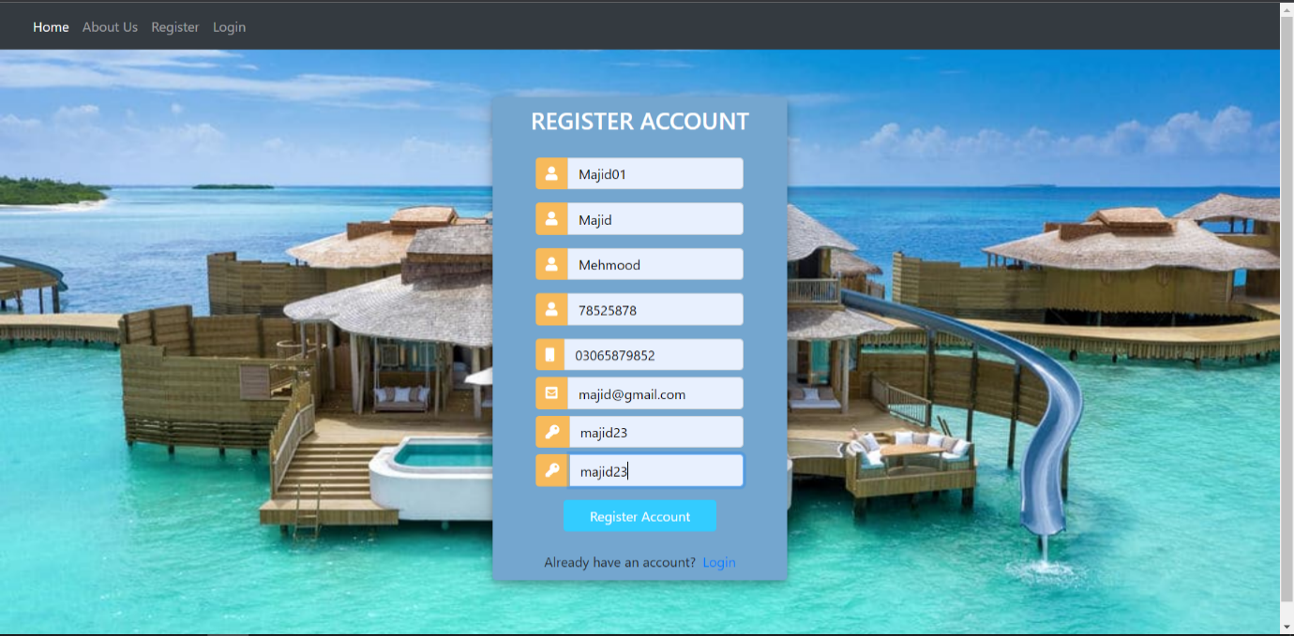

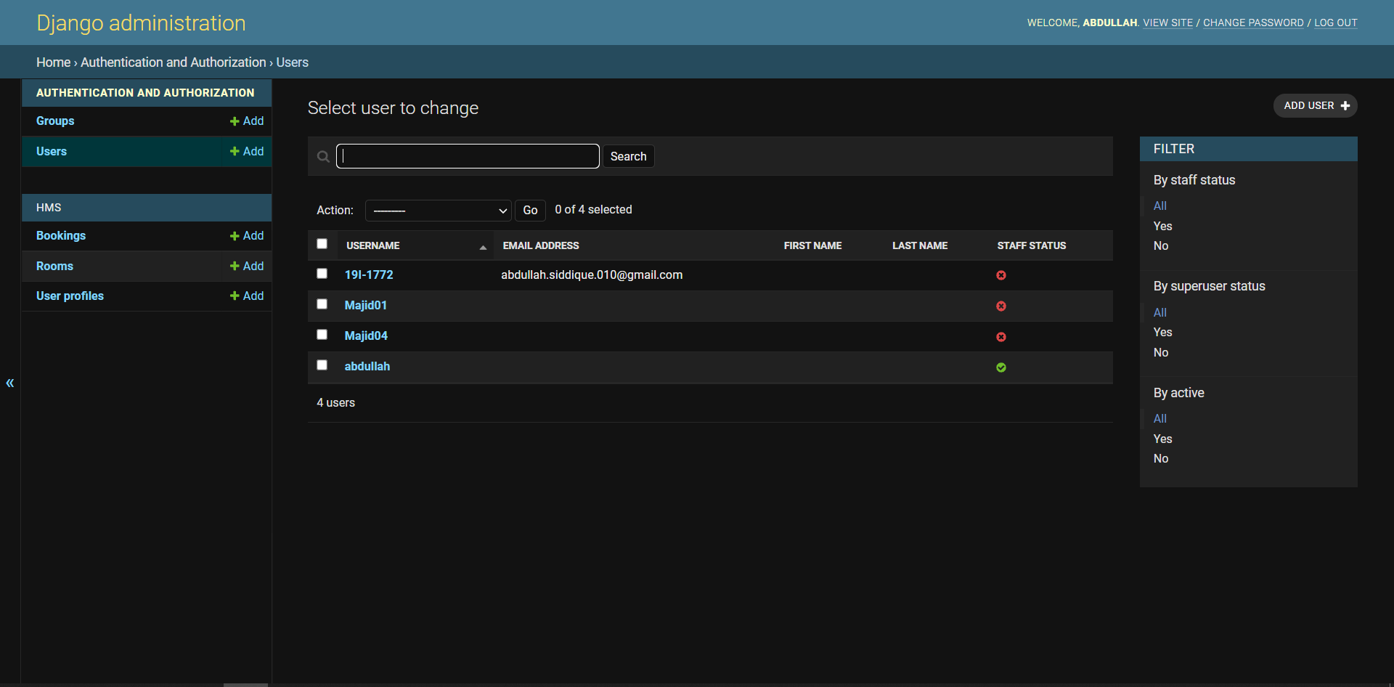

;login user wit tested

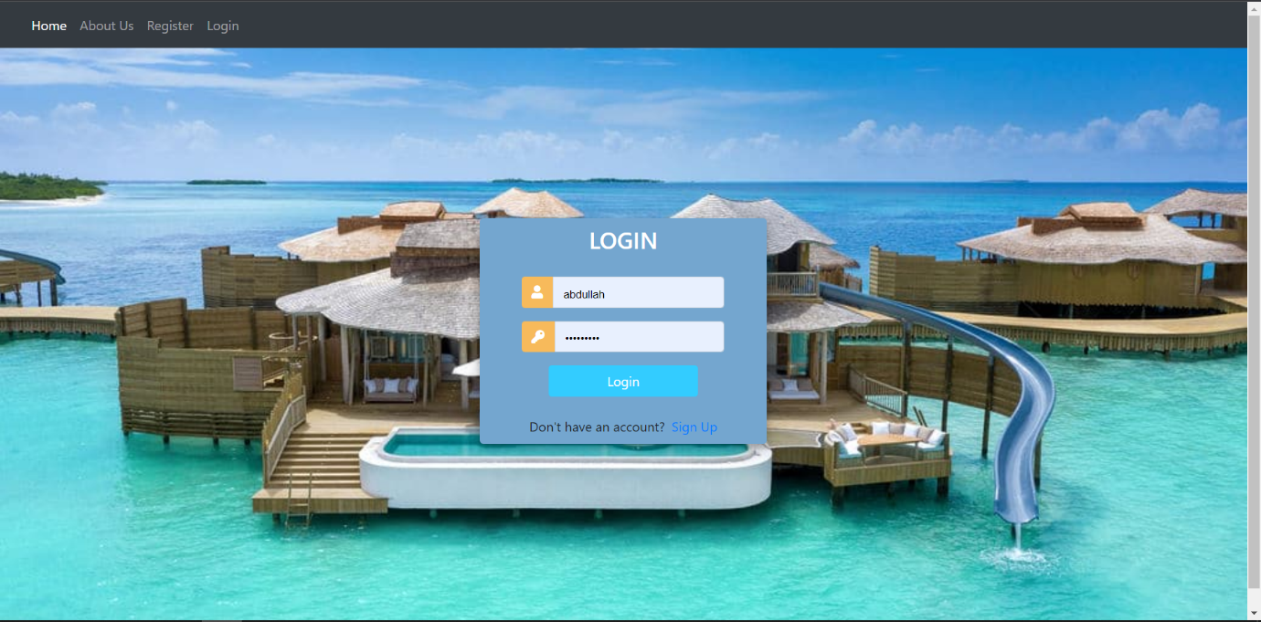



User made a booking showing in db and stored in db

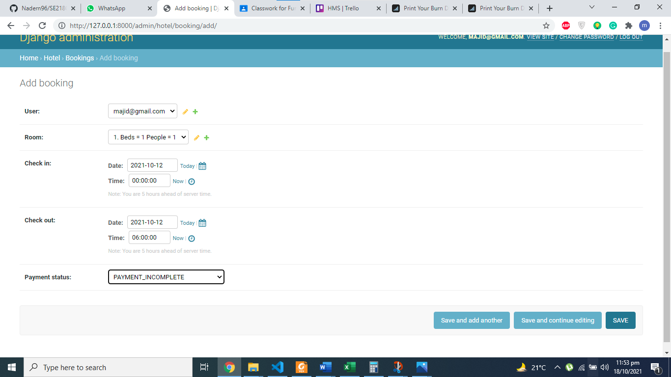



Name of person being shown



Types of room being shown

As for payment we applied the following user story guidelines:

1. As a user I want to be able to pay for my reservation online using my credit/debit card in order to complete my online reservation.

Implementation of this was done using an algorithm that validates a card that whether it is a Mastercard or VISA credit card. This algorithm checks the card validity or the customer can also pay on arrival so customer can have a variety of options to pay from.

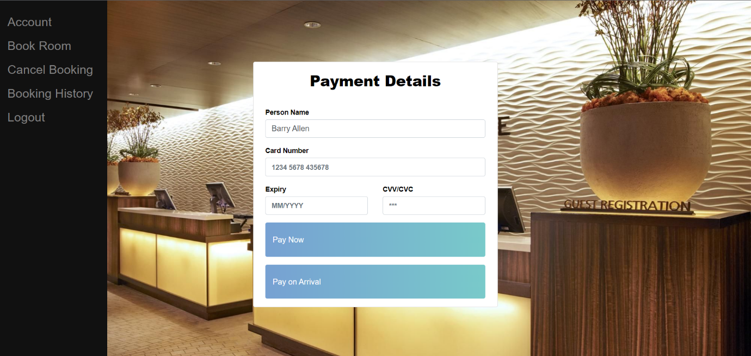

1. As a user I want to receive an email confirmation of my room change in order to have reassurance of my change.

As with all changes the user cannot directly change his booking so a change form in which a user types in his request and that is submitted to the admin of database and then after verifying the details the admin changes the details and sends an email that his required changes are made.

User submits a form requesting changes made to his booking. Automated not allowed as it was assessed that giving too much control to user would create security vulnerability plus losses to hotels so manual updating was required so that admin can verify a change.

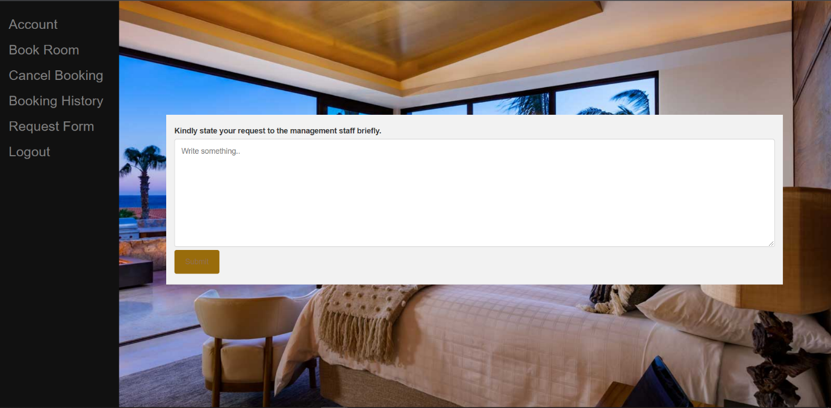

User has received confirmation that changes has been made to his booking.

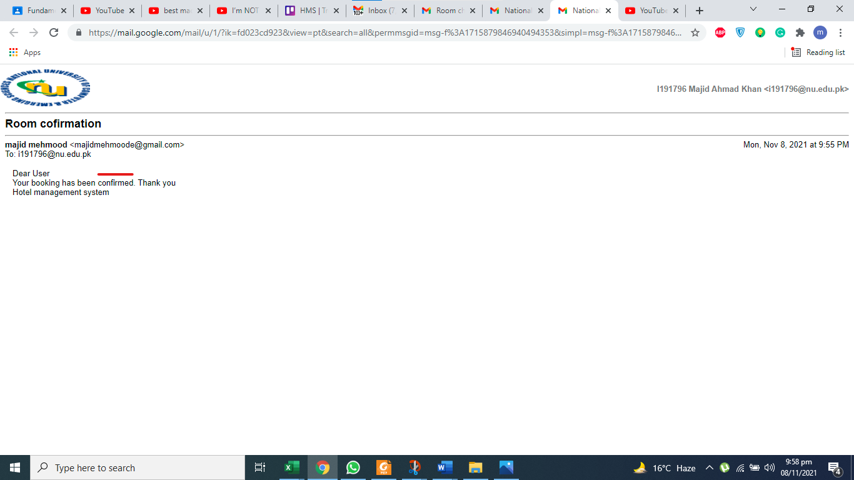

1. As a user I want to receive an email confirmation of my room booking.

To implement this the user entered his email and so after receiving the email by database an automated email is generated and user is given a confirmation of his booking. This improves security of the website and the user is reminded that he has made the booking.

As you can see user must type his email address to receive his confirmation message.

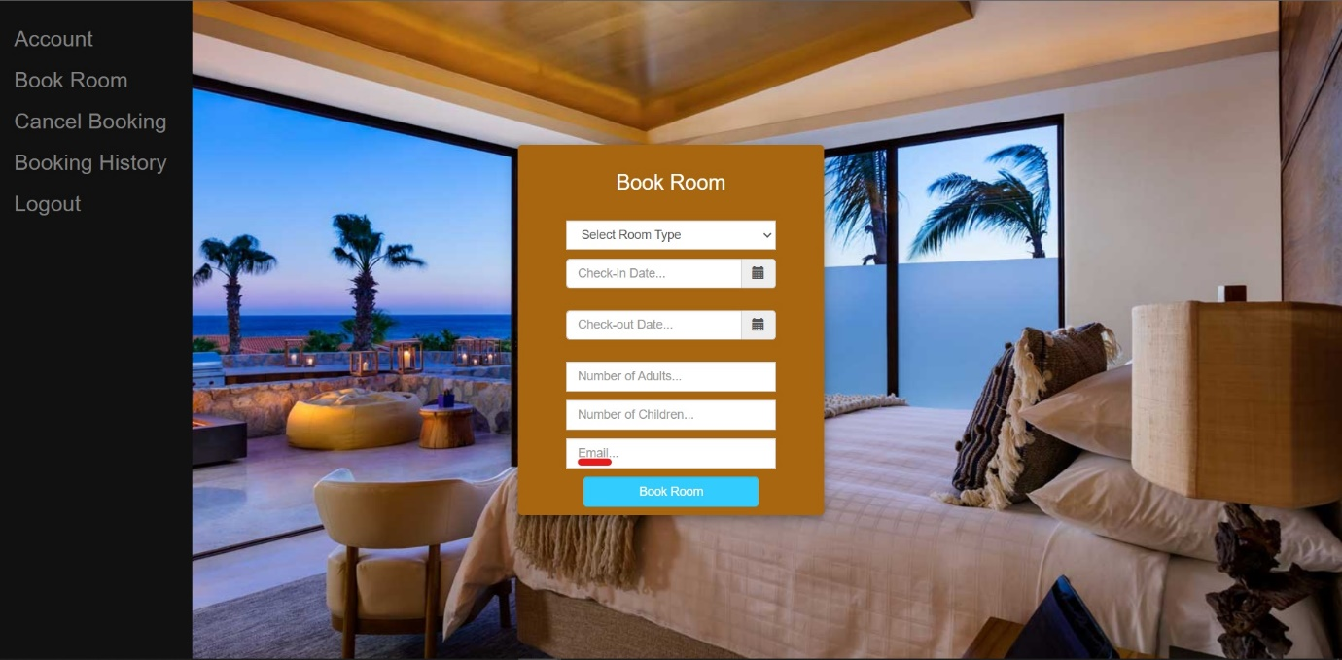

User has received confirmation message

